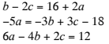
1. What is the solution to the system of linear equations?

- $(5,3,-1)$
- $(5,-1,3)$
- No solution
- Infinitely many solutions

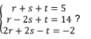

2. What is the solution to the system of linear equations?

- No Solution
- $r=2, s=2, t=-1$
- $r=4, s=-3, t=4$
- Infinitely many solutions

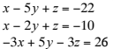
3. What is the solution to the system of equations?

- $(3,4,-3)$
- $(4,-3,-3)$
- Infinitely Many
- No Solution

4. In triangle TUV, the measure of angle U is twice the measure of angle T. The measure of angle V is 80 more than that of T. Formulate the system of equations for this situation.

Equation 1:__________________________________________
Equation 2:__________________________________________
Equation 3:__________________________________________

5. Customer A spent $18 on a plate of brisket, two sides, and a drink. Customer B spent $10 on a plate of brisket and a drink. Customer C spent $57 on three plates of brisket, six sides, and four drinks.
Which augmented matrix best represents the system of linear equations that could be used to determine the price of each item?
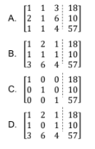
6. What price did the customers pay for a plate of brisket?
- $14
- $7
- $4
- $3

7. A manufacturer of pink erasers has three machines that, when all working, produce 24,000 erasers per day. When only machine A and machine C are operational, they produce 14,400 erasers per day. Together, machine B and machine C produce 18,240 erasers each day.

Which system of linear equations could be used to determine the daily quantity of pink erasers produced by each machine?
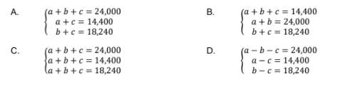

8. Joy spent a total of $116 on 30 plates, 40 cups, and 4 packages of napkins. Jay spent $1000 on 250 plates, 300 cups, and 50 packages of napkins, while Jon spent $189 on 55 plates, 55 cups, and 6 packages of napkins.
Which system of linear equations could be used to determine the price of each type of party supply?

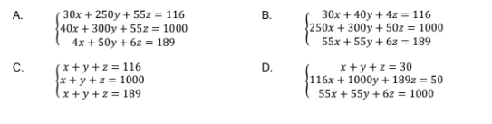

9. Which response best describes the price of each type of party supply?

- Plates cost $2 each, cups cost $1 each, and each package of napkins costs $4.
- Plates cost $30 each, cups cost $40 each, and each package of napkins costs $4.
- Plates cost $1.50 each, cups cost $2.50 each, and each package of napkins costs $5.
- Plates cost $116 each, cups cost $1000 each, and each package of napkins costs $189.

